IELTS Academic Writing Test
Test Format and Tasks
- 60 minutes
- 2 writing tasks:
  - Task 1: 20 minutes, 150 words.
  - Task 2: 40 minutes, 250 words.
- Words are counted by the examiners, so don't write too many or too few words.
- Tip - learn how many words you usually write on a line, and how many lines = 150 and 250 words, so you don't waste time counting words in the test.
Answers
- Must be written on the answer sheet.
- Must be written in full.
- Notes are not acceptable as answers.
- Notes may be made on the question paper, but cannot be taken from the test room.
Task 1: (20 minutes, 150 words)
This task will require you to interpret a diagram or table, and present the information in your own words. The writing skills needed for this task are:
- Organise, present and possibly compare data
e.g. money people spend on different forms of entertainment.
- Describe stages of a procedure or process
e.g. the stages of human evolution
- Describe on object or event or series of events
e.g. How the water cycle works
- Explain how something works
e.g. How a car engine works
Task 2: (40 minutes, 250 words)
In this task you will be presented with a point of view or argument or problem. The writing skills needed for this task are:
- Present and justify an opinion
e.g. Do you think trial by jury should be used in all criminal cases?
- Compare and contrast evidence, opinions and implications
e.g. How effective is it to reward good work with extra money?
- Evaluate and challenge ideas, evidence or an argument
e.g. "Failure shows desire wasn't strong enough". To what extent do you agree?
Assessment Criteria
You must respond appropriately in terms of:
- Register - formality and politeness;
e.g. no short forms
- Organisation - clear and logical
- Style - academic;
e.g. no rhetorical questions, no exclamations, no extreme opinions, use tentative expressions such as "this appears to be" or "this is probably due to'
- Content - relevant and complete
Task 1: some tips for describing data in a chart or table
When writing Task 1 bear in mind these points:
- Task Fulfillment – answer the question completely
- Coherence – use sequencing words
e.g. Firstly, Secondly, Finally
- Cohesion – using anaphoric reference
e.g. "this", "it", "he", "and", "but" and synonyms
- Vocabulary – use a wide range, appropriate and academic
- Sentence Structure – be concise but not simplistic
e.g. correct use of relative clauses.
Example for Task 1: describing data in a chart
You should spend about 20 minutes on this task.
The graph below shows the different modes of commuter transport used in London in 1960, 1980 and 2000.
Commuter Transport in London
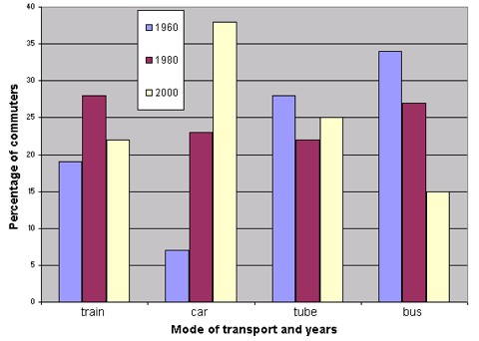
Write a report for a university lecturer describing the information shown. You should write at least 150 words.
Preparation for Task 1
Practise with a partner:
- Identify the main trends for each mode.
- Identify any large increases or decreases.
- Are there any clear and consistent directions?
- Does anything seem particularly significant?
- Are there any clear relationships between modes or percentages?
Model answer for Task 1
Model answer
The graph shows the changing patterns in commuting by train, car, tube or bus for commuters in London in the years 1960, 1980 and 2000.
The number of people using trains at first rose from just under 20% in 1960 to about 26% in 1980, but then fell back to about 23% in 2000.
Use of the tube has been relatively stable, falling from around 27% of commuters in 1960 to 22% in 1980, but climbing back to reach 25% by 2000.
On the other hand, the use of cars increased steadily from just over 5% in 1960 to 23% in 1980, reaching almost 40% by 2000, whereas the popularity of buses has declined since 1960, falling from just under 35% in 1960 to 27% in 1980 and only 15% in 2000.
The graph indicates the growing use of cars for commuting to work between 1960 - 2000, and the corresponding decline in the popularity of buses from being the most popular mode of transport in 1960 to the least popular in 2000.

The text above given in the model answer consists of 174 words in 5 paragraphs which describe the data in the chart. These 5 paragraphs can be further analysed as comprising:
- Introduction
- Figures on the use of trains
- Figures on the use of the tube
- Figures on the use of cars and buses
- Conclusion
Task 1: Introduction
The introductory paragraph states the main purpose of the chart, written in paraphrase using the writer's own words.
Introduction: paragraph 1
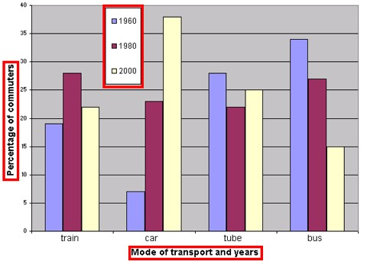
The graph shows the the changing patterns in travelling to work by train, car, tube or bus for commuters in London in the years 1960, 1980 and 2000.
Task 1: Trains
The second paragraph describes the data for the use of trains given in the chart, written in the writer's own words.
Trains: paragraph 2
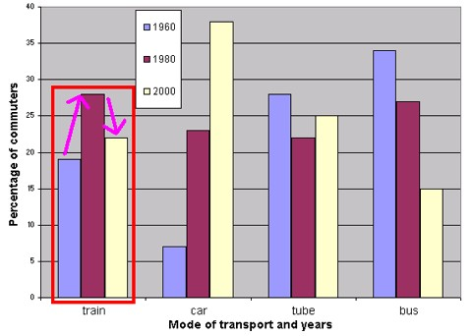
The number of people using trains at first rose from just under 20% in 1960 to about 26% in 1980, but then fell back to about 23% in 2000.
Task 1: the Tube
The third paragraph describes the data for the use of the tube given in the chart, written in the writer's own words.
The Tube: paragraph 3
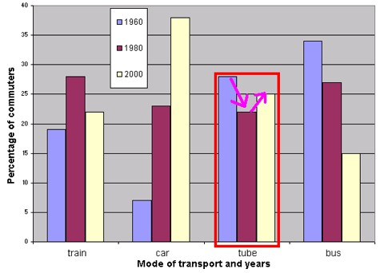
Use of the tube has been relatively stable, falling from around 27% of commuters in 1960 to 22% in 1980, but climbing back to reach 25% by 2000.
Task 1: Cars and buses
The fourth paragraph describes the data for the use of cars and buses given in the chart, written in the writer's own words.
Cars and buses: paragraph 4
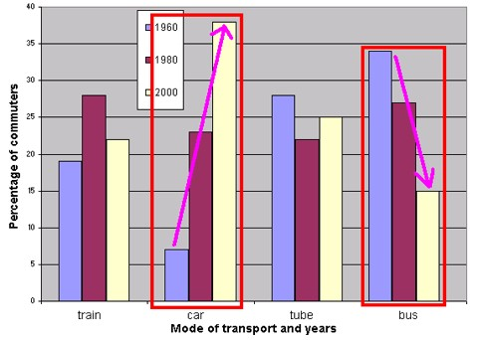
On the other hand, the use of cars increased steadily from just over 5% in 1960 to 23% in 1980, reaching almost 40% by 2000, whereas the popularity of buses has declined since 1960, falling from just under 35% in 1960 to 27% in 1980 and only 15% in 2000.
Task 1: Conclusion
The concluding paragraph summarises the main findings of the chart, written in the writer's own words.
Conclusion: paragraph 5
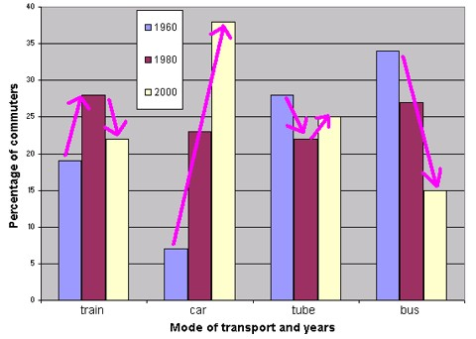
The graph indicates the growing use of cars for commuting to work between 1960 - 2000, and the corresponding decline in the popularity of buses from being the most popular mode of transport in 1960 to the least popular in 2000.
The main writing skills performed in Task 1 are:
- Describing numerical data
- Identifying differences and similarities
- Comparing and contrasting
- Identifying and describing trends
Task 2: presenting a point of view, argument or problem
In Task 2 candidates are presented with a point of view, argument or problem and are required to write an essay of about 250 words about this.
Task 2 is assessed on:
- Quality of Arguments – how logical and well-considered they are
- Ideas and Evidence – how you support your points
- Communicative Quality
- Use of Vocabulary and Sentence Structure
Example for Task 2: presenting your opinion
You should spend about 20 minutes on this task.
Present a written argument or case to an educated reader with no specialist knowledge of the following topic:
Some businesses now say that no one can smoke cigarettes in any of their offices. Some governments have even banned smoking in all public places. This is a good idea but it takes away some of our freedom.
What are your opinions on this?

Task 2: some tips for presenting your opinion
When writing Task 1 bear in mind these points:
- Read the question carefully and read it several times.
- Decide what the focus of the task is.
- The first sentence is sometimes background information, the focus of the essay and the question come after.
- Decide what the task requires you do.
Strategies: organising your essay
First decide on the key ideas about the topic. How many ideas can you cover in 250 words?
- After you have listed your ideas, you need to organise them.
- Do not produce a list of ideas without development.
- Select some supporting points for each key idea in your list.
- Think about your own experience – do you have any further points to add.
Strategies: content of your essay
Make sure that you:
- respond to each point mentioned in the task.
- answer completely
Make sure that you do not:
- misunderstand the question
e.g. smoking in Government offices
- write about something not required in the question; e.g. banning smoking completely
- answer only part of the topic
e.g. you discuss whether it is a good idea, but don’t mention freedom.
Strategies: planning
Allow some time to think about the question and:
- note down clear and relevant ideas
- make a brief plan of the organisation and content of your answer
Your essay should have:
- an introduction
- a main body where you present your arguments
- a conclusion
Example plan:
- Intro – smoking in businesses & Govt. 0ffices - good idea? freedom?
- Body - present your arguments
  - Smoking in businesses
Good idea?
- Smokers may work better if they can smoke
- Passive smoking – objections from other staff
Takes away freedom?
- Businesses have the right to limit staff activities
  - Govt. restrictions on smoking in public places
Good idea?
- Costs to society - Passive smoking, litter, health care
- Benefits to society – tax revenue, pleasure of smokers
- Pressure groups – smokers, tobacco companies, sponsors
Takes away freedom?
- Govt. has the right to regulate citizens’ activities
- Will citizens support regulation?
- Conclusion
Strategies: the Introduction
The Introduction is important: because it gives the first impression to your reader. It should:
- be only a few sentences, concise and to the point
- introduce the topic
- outline the main points
- define what you understand by the task
- show how you intend to approach the task
Strategies: the Body
The Body of your essay is the main part where you will present the arguments on both sides. It should:
- present both sides of the argument
- give some evidence or logical reasons to support the main points you have made
- try to be fair in weighing up the arguments
Strategies: the Conclusion
The Conclusion is important because it gives the opportunity to leave a good impression with your reader. It should:
- be only a few sentences, concise and to the point
- summarise the main points you have made
- express a final opinion, statement, or recommendation as appropriate to the task
Example Introduction

Introduction
Restricting smoking in offices and public places is controversial, since although non-smokers may think this is a good idea, smokers naturally may not. It may also be seen as an interference with people’s freedom. Different cultures may have varying attitudes as to whether businesses or governments have the right to ban smoking in certain places.
Example Body
Body
Banning smoking in the workplace may not be a good idea because smokers may work better if they can smoke. However, passive smoking can cause objections from colleagues. Although such bans may reduce freedom, it is widely accepted that businesses have the right to regulate staff activities. Governments too may also ban smoking in public places, which may be beneficial by reducing the costs to society of smoking such as litter and health care.
However, smoking in public may also bring some benefits to society, for example in tax revenue and of course the pleasure of smokers. Also, pressure groups such as tobacco companies may discourage restrictions on smoking.
As for freedom, in all societies the government has the right to regulate citizens’ activities. It is therefore possible that as more citizens come to believe that the disadvantages of allowing smoking outweigh the advantages, then they would increasingly support such bans.
Example Conclusion
Conclusion
As a non-smoker I believe that restricting smoking in workplaces and in public is a good idea. I can also understand the opinion of smokers that banning smoking in such places limits their freedom. However, if the effects of smoking were limited to smokers I would oppose bans, but as smoking affects the health of others, I support them.

